RAJALAKSHMI ENGINEERING COLLEGE

**RAJALAKSHMI NAGAR, THANDALAM – 602 105**



|  |
| --- |
| **CS23A34**  **USER INTERFACE AND DESIGN LAB** |
| **Laboratory Observation NoteBook** |

**Name :** THARUN KUMAR S

**Year/Branch/Section :** II/CSE/D **Register No. :** 230701393 **Semester :** IV

**Academic Year:** 2024-25

**Ex. No. : 5b Date : 29.03.2025**

**Register No. : 230701393 Name : THARUN KUMAR S**

**Simulate the life cycle stages for UI design using the RAD model and develop a small interactive interface using OpenProj**

# AIM:

The aim is to recreate the lifecycle stages of UI design using the RAD model and design a small interactive interface with OpenProj

# PROCEDURE:

Tool Link: https://sourceforge.net/projects/openproj/

## Step 1: Requirements Planning

1. Gather Requirements:
   * Identify key features and functionalities needed for your interface.
   * Example: A simple "Login" and "Register" interface with debug logs.
2. Define Use Cases:
   * Specify use cases for user login and registration.
   * Example: User logs in with valid credentials, user registers with a new account.

Output in OpenProj:

* Create a new project.
* Add tasks: "Gather Requirements" and "Define Use Cases."
* Set durations and dependencies for each task.

## Step 2: User Design

1. Sketch Initial Designs:
   * Draw rough sketches of the "Login" and "Register" screens on paper.
2. Create Digital Wireframes:
   * Use a tool like Figma or Sketch to create digital wireframes.

Example Wireframes:

1. Login Screen: Username field, Password field, Login button, Register link.
2. Register Screen: Username field, Email field, Password field, Confirm Password field, Register button.

Output in OpenProj:

* + Add tasks: "Sketch Initial Designs" and "Create Digital Wireframes."
  + Allocate time and resources to complete these tasks.

## Step 3: Rapid Prototyping

1. Develop Prototypes:
   * Use a tool like Axure RP to convert wireframes into interactive prototypes.
2. Test Prototypes:
   * Share prototypes with stakeholders for feedback.
   * Collect feedback and iterate on the design. Output:

* Interactive prototypes for "Login" and "Register" screens. Output in OpenProj:
* Add tasks: "Develop Prototypes" and "Test Prototypes."
* Set dependencies and milestones.

## Step 4: User Acceptance/Testing

1. Review Prototype:
   * Conduct user and stakeholder reviews.
2. Conduct Usability Testing:
   * Perform usability testing and document feedback.

Output:

* Documented feedback and test results. Output in OpenProj:
* Add tasks: "Review Prototype" and "Usability Testing."
* Track progress and resources.

## Step 5: Implementation

1. Develop Functional Interface:
   * Implement final designs and functionalities based on feedback.
2. Integrate Backend (if required):
   * Connect the UI with backend services for tasks like user authentication.

# OUTPUT:

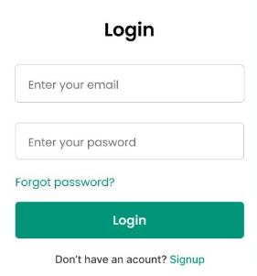 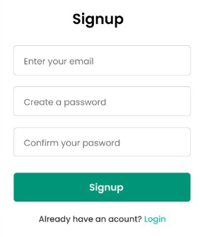

**RESULT:**

Hence the lifecycle stages of UI design using the RAD model and design of a small interactive interface with OpenProj has been successfully executed.